ASSESSMENT

Complexity Analysis | 25 total (each question is worth 5)

Code Sample 1 (5 marks):
There is a loop num run N times (until finding solution)
here is one variable num, one variable desirednumb,
Time complexity ; is O(N)
the space complexity is N+1 +1=O(N+1+1)=O(N)

Problem Sample 2 (5 marks):
The code runs N times
There are N variables
The time complexity is O(N)
The space complexity is O(N)

Code Sample 3
The code runs once
There are two variables
The time complexity is O(1)
The space complexity is 1+1+1= O(3)=O(1)

Problem Sample 4 (5 marks):
The code runs N/2 times
There are 2 variables
Time complexity O(N/2)
Space complexity O(1)

Algorithms 1 (Coding) | 25 (1 question)
def isValidSubsequence(array, sequence):
i = 0
for number in array:
if i == len(sequence):
break
if sequence[i] == number:
i += 1
return i == len(sequence)

The code is run N times (depends on the array size)
There is two variables
Time complexity is O(N)
Space complexity O(1+1)=O(1)

The best time complexity would be O(1), therefore the code should be run one time only so the perfect solution shouldn’t contain a loop

Algorithms 2 (Coding) | 25 (1 question)
The code is run N times (depends on the array size)
There is 3 variables
Time complexity is O(1+1+1+N)=O(N)
Space complexity O(1+1+1)=O(1)
The best time complexity would be O(1), therefore the code should be run one time only so the perfect solution shouldn’t contain a loop

Concept Generation & Prototype (Design) | 25 (1 question)

- who is the user?
  - The user of this app should be anyone who has access to a smartphone (should be available for Ios, android etc)

- Design the application / - : The music application should contain
  - use of a API to access a set of music
  - a welcome page with a research bar to look for a specific song/artist/playlist and a navbar to navigate easliy between pages
  - a page where it is displayed a music media player, so the user can stop/replay/go forward/backward
  - a profile page (optional)

- what platform (web, mobile)? A music application should be available for mobile

- What may it look like ?
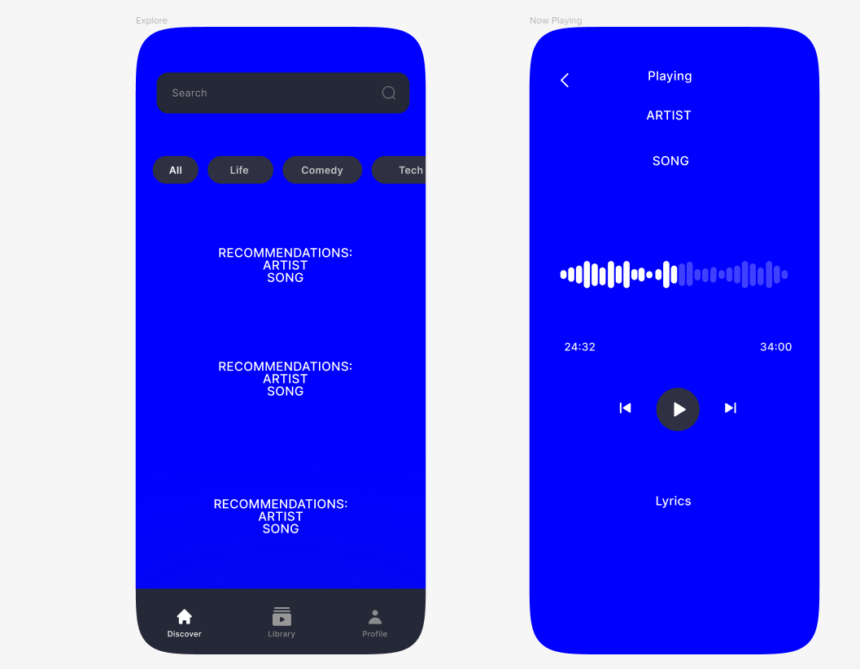
- What colours would you use and why?
  - I will use the color blue as background because i learnt that blue represents calm and peace in the color spectrum and i would like the user to feel at peace while using my application. Important information would be in white for the user to not feel overhelmed by information.

- What design heuristics and principles will you be following? What made you choose this design?

